
Database Management Systems
Practical Lab File

Submitted in partial fulfilment of the requirement of the degree of
BACHELOR OF TECHNOLOGY (FSD)
Semester-IV

to
Dr Preeti Rathi
Assistant Professor (SOET)
by
Adit Ghosh 2401350016

GitHub Link: https://github.com/adit-ghosh/dbms-practical-file-2401350016

INDEX

S  No | Content | Page No
1. | Index | 1
2. | To study and implement various DDL commands to create and modify a table in MySQL. | 2
3. | To study and implement various DML commands to insert, retrieve, update, and delete data. | 4
4. | To study and implement DCL commands to control access and permissions in MySQL. | 6
5. | To implement aggregate functions MIN(), MAX(), SUM(), AVG(), and COUNT() on a table in MySQL. | 8
6. | To perform data retrieval using conditions (greater than) and sorting techniques using ASC and DESC in MySQL. | 10
7. | To implement NATURAL JOIN and EQUI JOIN on tables in MySQL. | 12
8. | To implement LEFT OUTER JOIN and RIGHT OUTER JOIN on tables in MySQL. | 14
9. | To implement SELF JOIN on a table in MySQL. | 16

Experiment 1
Aim: To study and implement various DDL commands to create and modify a table in MySQL.

Query:
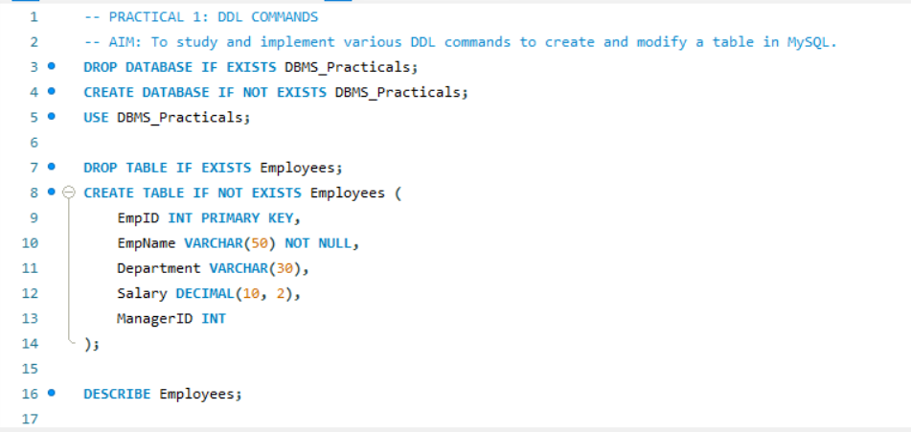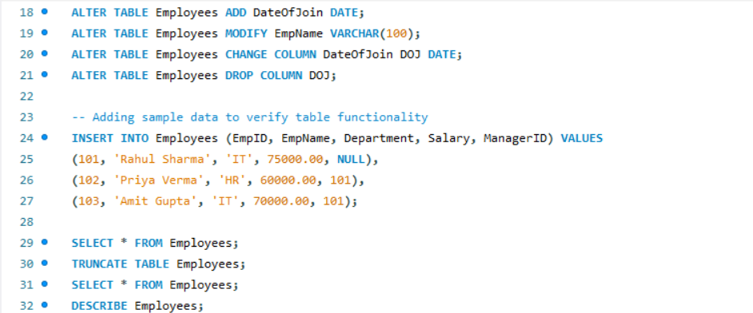

Output:
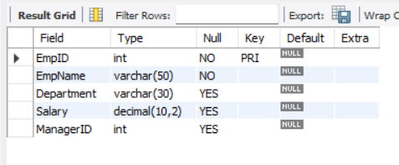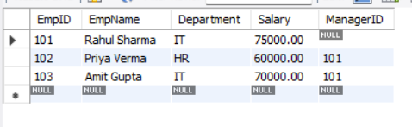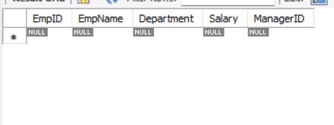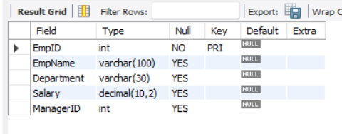

Experiment 2
Aim: To study and implement various DML commands to insert, retrieve, update, and delete data.

Query:
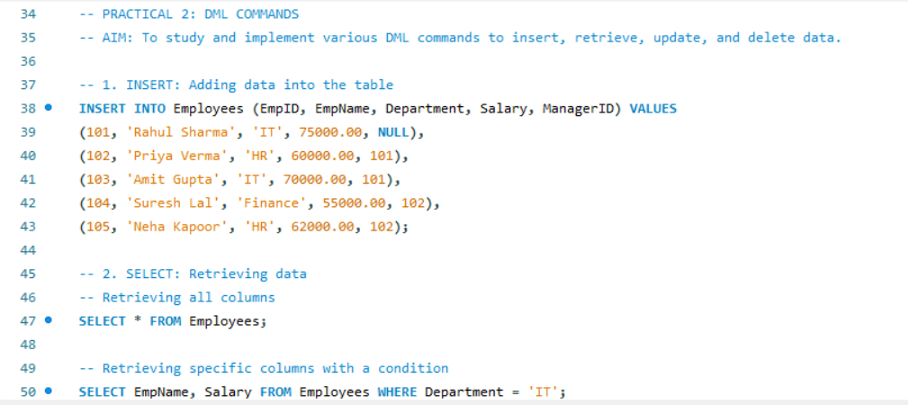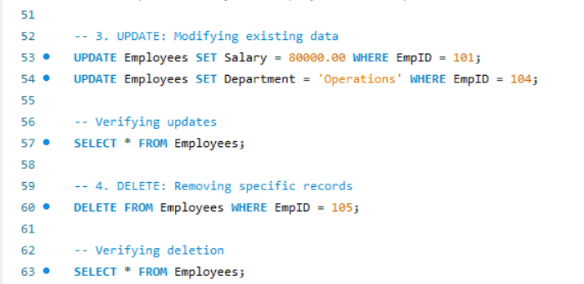

Output:
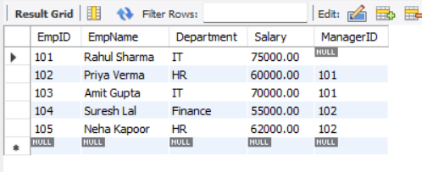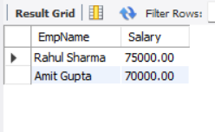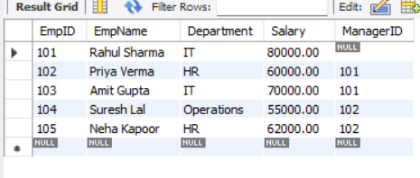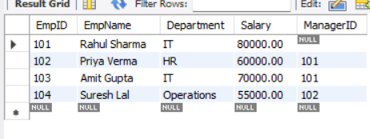

Experiment 3
Aim: To study and implement DCL commands to control access and permissions in MySQL.

Query: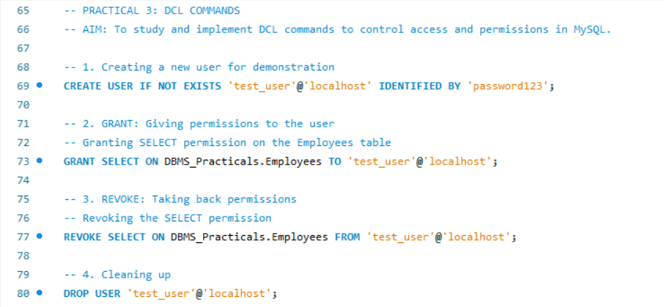

Output:

Experiment 4
Aim: To implement aggregate functions MIN(), MAX(), SUM(), AVG(), and COUNT() on a table in MySQL.

Query:
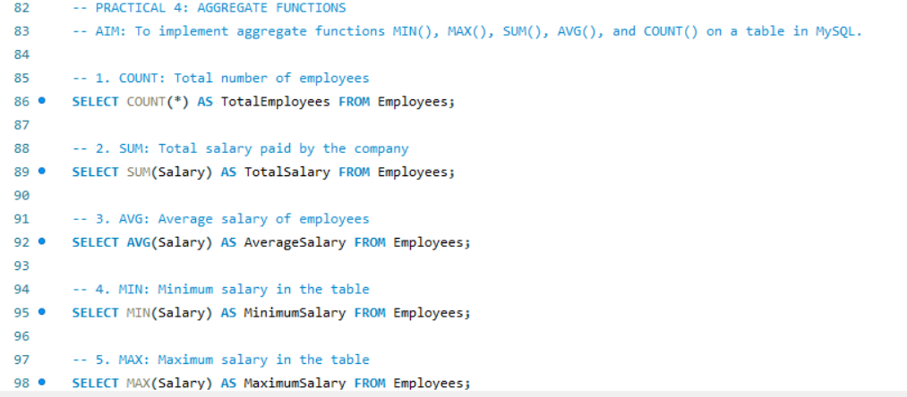

Output:
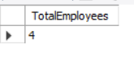
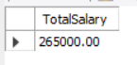
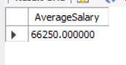
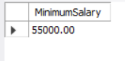
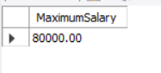

Experiment 5
Aim: To perform data retrieval using conditions (greater than) and sorting techniques using ASC and DESC in MySQL.

Query:
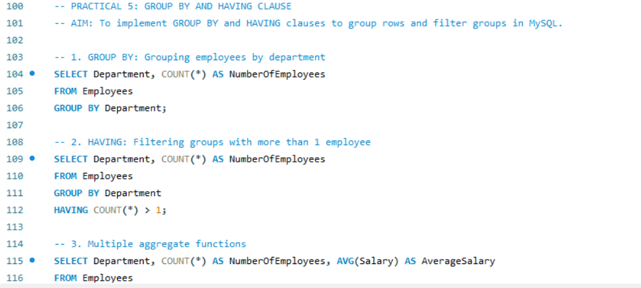

Output:
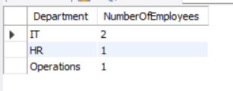
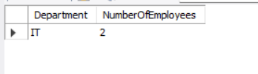
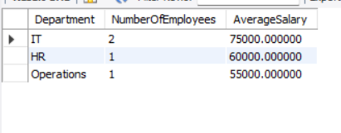

Experiment 6
Aim: To implement NATURAL JOIN and EQUI JOIN on tables in MySQL.

Query:
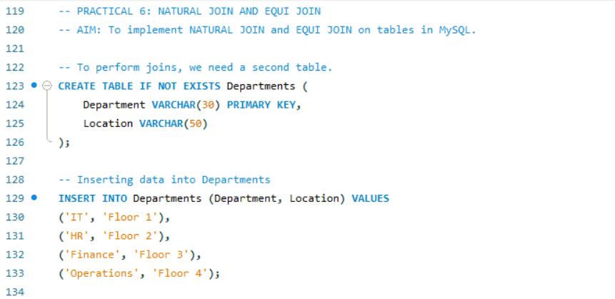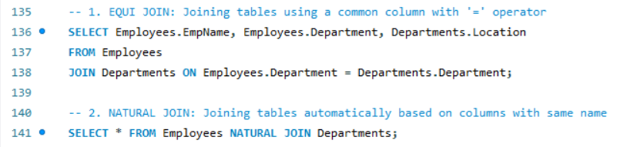

Output:
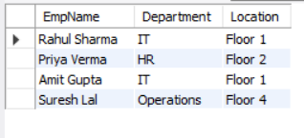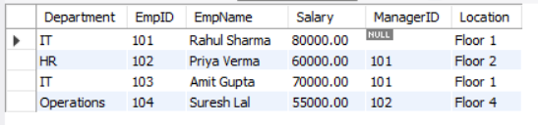

Experiment 7
Aim: To implement LEFT OUTER JOIN and RIGHT OUTER JOIN on tables in MySQL.

Code:
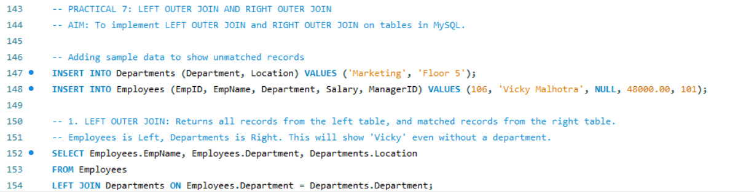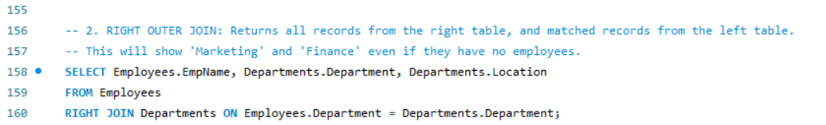

Output:
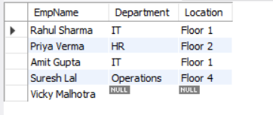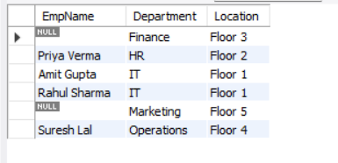

Experiment 8
Aim: To implement SELF JOIN on a table in MySQL.

Code:
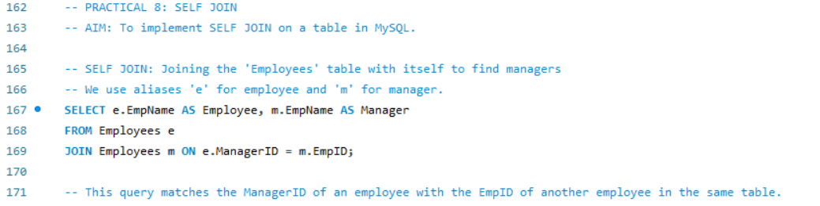

Output:
